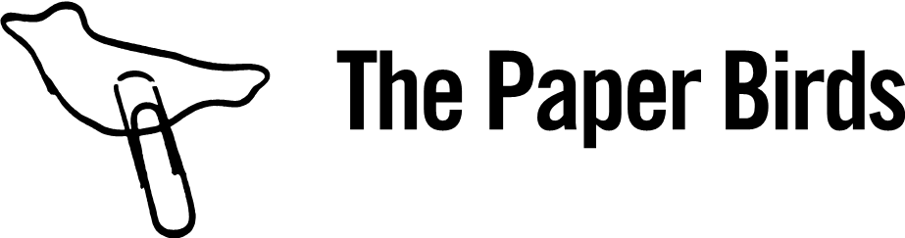

ORDER FORM
Please complete and return via email to education@thepaperbirds.com

DRAMA TEACHER’S NAME
DRAMA TEACHER’S EMAIL ADDRESS
POSTAL ADDRESS
FEE | £125.00 + VAT  Plus £12.00 postage & packing  TOTAL DUE: £162.00
EMAIL ADDRESS TO SEND INVOICE
WHERE DID YOU HEAR ABOUT THIS RESOURCE?
SCHOOL FINANCE DEPT. EMAIL ADDRESS
PURCHASE ORDER NUMBER FOR INVOICE (If required)

Payment & Returns Policy
Upon submission of this form, an invoice will be raised to you for the full fee. Payment is due within 14 days. Your Theatre Creativity Cards will be sent to you within 5 working days of the receipt of this order form.
Returns cannot be accepted unless in un-opened and re-sellable box. If returned, buyer pays postage back to The Paper Birds

